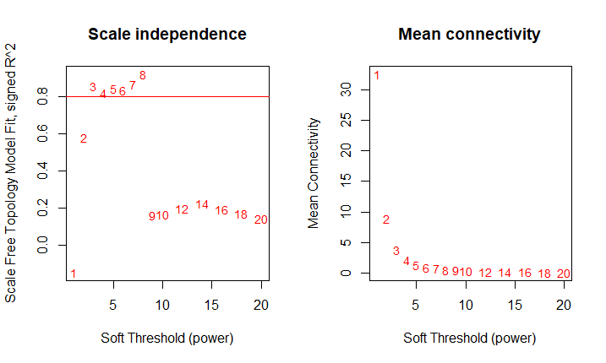

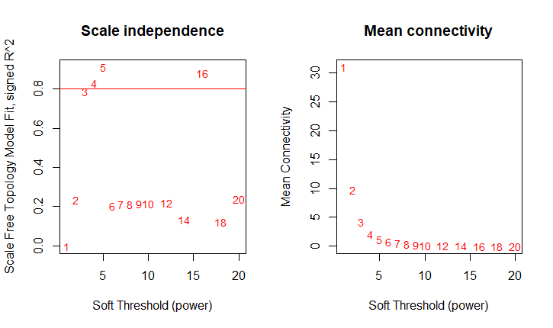

Supplementary Figure 1 – Plot of index of fit to a scale-free graph for values from 1 to 20 for a) 2000 and b) 2015 data. We determined the soft threshold, or the threshold for which a correlation can be considered an edge in the network, by selecting the value at the first peak (3 for 2000, 5 for 2015). This value was used to generate the adjacency matrix – where adjacency is Spearman correlation raised to a given power, to reduce noise.